INTRODUCTION/BACKGROUND TO MY INCIDENTS
I noticed (through many observations) how several teachers adopted approaches that directly challenged my own philosophy of teaching with some degree of success. This initially resulted in me contemplating over and questioning the underpinnings of my approach. My own Head of Dept. for example (Teacher A), opposed my own style with her ’teacher-centred’ approach (Garrett, 2008), which was effective, although divisive to my own style in the way it dealt with behaviourally challenged students.

In observations with Teacher A, I noticed her teacher presence was regimented; she was stringent, firm, assertive with how she dealt with all of her classes and the students conformed to her ideals and manner of teaching. My initial response was that this indicated successful inclusive practice (Sears, 1997), as she ascertained a sense of routine where expectations were inherently high. Teacher A was consistent in her approach with all of her different classes; albeit a behaviourally challenging bottom set Year 9, or a top set precocious Year 11.

If a student was late to class they were reprimanded accordingly. If a student would talk whilst on task, they were robustly sanctioned. The positives of this approach were that; class expectations were routinely high, behaviour (in majority of cases) was exemplary, and for the large part, learning was taking place. The same was with her conduct around the wider school too - she would exert her authority publicly to send a wider message that her word and school expectations were absolute. Fundamentally, students knew what to expect of Teacher A. However I found that simply replicating her approach was redundant to my own style. I thought her approach could be problematic for me being that it didn’t fit my teaching style in the practical classroom. Whilst a comprehensive approach such as this worked, I felt as a modern practitioner this approach would not allow me to differentiate/adapt - potentially leading me to marginalise students. Teacher A’s approach should have contravened my own in theory, however I was able to ‘magpie’ some aspects of her style. Aspects that I adapted to fit my own teaching personality.

This essay will discuss the development of my practice - exploring my reflective practice surrounding learners and learning in lieu of two crucial incidents - moving on from my consideration of teachers/teaching (and my philosophy of teaching) evidenced in the first assignment.

CRITICAL INCIDENT 1
Team teaching with Teacher A made me realise that the effectiveness of certain teaching styles revolves centrally around their practical employment. Teacher A asked me to have a zero-tolerance approach to any student who would try to engage in disobeying instructions when being ordered by the teacher. Whilst teaching a Set 2, Year 11 class with Teacher A, one student (Student A) was fairly vocal with regards to not wanting to read aloud to the class. Whilst I attempted to engage with the student by asking that the student read only a few lines – even giving them the option to remain seated whilst doing so (as everyone was standing up), Teacher A interceded and declared a C1 (warning) for Student A. The student continued to object, and in quick-fire succession Teacher A issued a C2 (final warning) and C3 (detention) as the student proceeded to be resolute. Consequently, Student A became agitated and angry, disrupting the class. Teacher A asked the student to leave and the confrontation required intervention from SLT.

At the time, I was shocked at how such an easily containable situation had escalated so rapidly. Technically speaking, Teacher A had (in essence) reinforced ownership of her class, however conflictingly this was at the expense of fostering a distasteful classroom harmony, and more importantly, devaluing “building relationships rooted in mutual respect” (TS P2, DfE). This interaction served as a reminder to myself of the school’s CPD session where de-escalation scripts in teacher-student exchanges were advocated in line with the school’s HEAR ethos (Humanity, Equality, Aspiration and Respect). [Appendix A].

Although the behavioural system was followed as it should, I didn’t believe it was exercised correctly. In terms of my actions here, I avoided confronting the student as Teacher A did, because I believed this would escalate the situation more, however still I couldn’t be passive and undermine my colleague. Therefore, to uphold professionalism (Teaching Standard 8B & Pt. 2, DfE, 2012 [online]), I did my best to contain the situation by neutrally telling the student to leave when asked. This experience taught me many things; to use good judgment in my own practice; focus on de-escalating situations; and to be aware of the school’s motto to ‘expect respect’ as mutually binding [Appendix B].

Alternatively, I understood why Teacher A persisted in her resolve. She wanted to create an inclusive space where all students were equal. As such she kept to a zero tolerance approach so expectations were high. Furthermore, I knew consistency with words/methods as a teacher is important (Mart, 2013) - whether this pertains to level of authority, or something as trivial as issuing a sanction/reward. Keeping to this is imperative in strengthening the ‘authenticity’ of the teacher (Brookfield, 2006, p.6).

After this incident had occurred, a reporting member of SLT spoke to myself and Teacher A, citing to us that there are some extenuating circumstances with this student at home (telling of his behaviour and outburst in this lesson). The knowledge I took from this experience is twofold - firstly, the incumbence of implementing a behaviour management strategy in a balanced and reasonable manner (ITN, 2004, p.9) and secondly of being judicious and using good judgment when dealing with negative behaviours. Where the culpability of a teacher’s professional duty is concerned, this should also be done with the common sense of taking into account individual factors such as the student’s prior behaviour; whether this behaviour is reactive or impassive in addition to other contributing influences (Pupil Premium, lack of Cultural Capital etc). If I were to relive this particular scenario again, I would try to passively encourage the student to read using a pounce and bounce technique, incentivise the reading through issuing rewards such as sleuths, or if this fails - elusively avoid pursuing a student altogether if he seems personally/emotionally disposed to not partaking in a certain activity – perhaps speaking to him in confidence after class in case of any wider underlying issue.

Overall, this taught me what not to do insofar it did what to do in a given situation. I learnt how I could carry myself differently to Teacher A to deescalate a potential situation, but on another note, I ‘magpied’ other aspects of her practice; for example her effective use of intonation and expressive use of body language in order to assert presence (detailed in critical incident 2).

Speaking to Teacher A about this experience post-incident, she elaborated on her style as a teacher. She explained her notion of zero tolerance and the fine line in establishing discipline on impressionable minds as they move into adulthood. Although I could agree with her, I interjected that I believed her role as Head of Dept, reinforced her ability to assume such an approach, and that this style wouldn’t be as swift and effective for me as a trainee (as it was for her). I did make her aware of some parts of her practice I would ‘magpie’, to which she agreed - citing she had adopted her style with time and experience, and that this is something that cannot be emulated so readily for various reasons.

REFLECTION IN TIME BETWEEN INCIDENT 1 & 2
Having experienced a lot more contrasting teaching styles during pupil trails in thetime between my first and second critical incidents at the school [Appendix C], I noticed how teaching styles were often at either side of extremes; either too ‘teacher-centred’, or opposingly too ‘pupil-centred’ (Garrett, p.34). I believed that adopting either/or lead to an incompatibility of positions – an instability in the teacher-student relationship leading to a “polarising” effect on students’ behaviour as Moyles (1992 p,6) suggests. Challenging students often rebelled to either extreme due to not having the right balance (Buchmann, 1992); hence I learnt that restoring equilibrium to either side was imperative to successful classroom management. Substantiating this with the most recent Ofsted report of my school, it was clear that to improve further the school must:

Improve pupils’ personal development, behaviour and welfare by making sure that all pupils in the secondary phase feel confident that they can talk to staff about their concerns, and that issues will be handled sensitively, [also to make students] believe that views are heard and taken into account by staff. (Ofsted, 2017 [online]).

Therefore, finding that teachers’ classroom management and students’ behaviour was mutually exclusive, I sought to augment a reciprocal relationship grounded in mutual respect by implementing a more ‘balanced’ teacher persona - compromising with the relation of learners and learning (within the student-teacher relationship), rather than an absolutist stance on my own teaching personality.

CRITICAL INCIDENT 2
Whilst teaching a set 5 Year 11 class, there was an incident between myself and a male student (Student B), who refused to listen to my instruction. The student was known to be quite rebellious, with a record of internal exclusions and documented behavioural problems. The student was producing minimal work in contrast to his peers and I believed him to be distracted sitting by his peer in the lesson (despite it being his seating plan seat). Consequently, I requested he move to the front. Though was not the first time I had taught this class, I felt that this particular student assumed he could take advantage of me as a newer teacher by arguing with me. Student B was obstinate in his response to instruction, stating he would begin working immediately and to leave him seated where he was.

I calmly but assertively explained I did warn him beforehand and that I had not issued a consequence for him yet, so rather than making me delay the lesson any further, he should move. He aggressively repeatedly he had not done anything wrong, which I matched by increasing my own intonation of voice (contrastingly) in a manner of assertiveness (not confrontational) as (Rogers, 2015) suggests. Remaining calm and professional in my demeanour, I clarified that I had not stated he did anything wrong, rather I was telling (not asking) him to move for my own reasons.

Typically, this would have been enough for a student to follow the given instruction in any other interaction, but this student still disobeyed. Considering my foreknowledge of this student’s background, I responded according to his behaviour. Using overt body language but (still) maintaining a calm and imperative tone (Milne, 2010), I reminded him his options were to move to the seat I had chosen for him and show me he is capable of working; only then would I ‘think’ about moving him back, or he would force me to issue a more serious consequence – whilst doing this I reminded him I was respecting him as he was a young adult, not a child, however that he was undermining his own position and was going to force me to treat him like a child. The short exchange here was admittedly prolonged, however it was successful as the student moved to the seat I had instructed with no disruptions taking place thereafter.

Schindler (2009, [online]) makes a distinction between 5 forms of teacher power. He argues the use of ‘referent’ and ‘coercive’ power together as being optimal in constructing personable relationships built on mutual respect (referent) whilst still constructively drawing lines and boundaries (coercive). I acted here to exercise my coercive power without compromising my referent power. My method amalgamated the “right combination of moderate dominance with moderate co-operation” as cited by a wide consensus of scholars (Leary 1957; Wubbels et al 1999; Brekelmans, Wubbels & Creton, 1990). Student B’s behaviour improved for the remainder of the lesson, and I successfully de-escalated the situation. I preferred this approach to referring instantly to the school’s behavioural policy due to my foreknowledge that he becomes egregious and despondent when reprimanded using this. [Appendix D].

I was successful here due to the emphasis I placed on the reciprocity of exchange. Sheets (1996) suggests students are not passive recipients of teacher actions, but active agents in choosing to resist or comply with acquiescence. Therefore by speaking to him in a positively assertive manner as such was I able to; a) model positive behavioural development in a wider context and b) directly influence a like-for-like response back to me. More broadly this links to both the ‘dyadic social exchange’ as characterised by Patterson and Reid (1970) and Bandura’s Social Learning Theory (1977). In a modern educational climate, it neither alludes to archetypal positive or negative reinforcement; rather, it ameliorates a “mutually reinforcing social exchange [whereby] the positive behaviour of one reinforces the positive behaviour of the other, with the probability of such interactions occurring in the future increased” (Shores et al, 1993, p.92). Thus, appropriation of a firm but fair approach with regard for the student-teacher dynamic here resulted in a successful outcome.

Paul Willis (1997) in his study on 12 working class secondary school ‘lads’ found that such students exhibited a “counter school culture” built around inclination towards heightened masculinity and challenging obedience (p.76). I knew from previous consultation with his Head of Year, that Student B had no father or male role model figure at home. Furthermore I knew that other contributing factors were; the school being predominantly male student heavy, and also myself being the sole male English teacher in the department. Given this, I appropriately managed Student B’s emotional response; i.e. a natural instinct to compete for masculine authority (Delamont, 2012).

Hargreaves (2000) furthers that “classroom emotions are seen to intrude into learning from the outside” (p.822), therefore the way I handled this interaction complemented my overall teacher presence to the class by detracting from any negative harmony - sending a wider objective message of myself as an authoritative figure/role model (Martino, 2008) who has the students’ best interests at heart.

Jennings and Greenberg (2009) put forward that “successful teacher implementation is to create an environment that is conducive to SEL, for example, providing a positive role model and facilitating interpersonal problem solving and conflict resolution” (p.504). I managed to keep faithful to my philosophy of teaching whilst demonstrating humility, respect and empathy.

REFLECTION
Incident 1 provided the opportunity for reflection-in-action (Ghaye, 2011) which informed my reflection-with-action in incident 2. I was successful in the latter as I stayed mindful to the efficacy of the student-teacher relationship as a “interpersonal dynamic” (Frymier and Houser, 2000, p.324), I demonstrated “high standards of ethics and behaviour […] treating pupils with dignity, building relationships rooted in mutual respect [and] observing proper boundaries” (TS Pt 2, DfE, [online]). The student in the end listened and responded willingly as a “purposive act” (Schlosser, 1992, p.74) based on their trust of the interpersonal relationship.

Baker (1999) instigates that the breakdown of the student-teacher relationship stemming from a lack of understanding is what intensifies potential conflicts. I can advocate this as my own success of behaviour management is grounded circularly in building of positive relationships, mutually respectful communication and use of good judgement.

Alternatively, Hastings and Bham (2003) point towards ‘teacher burnout’. They argue negative student behavioural patterns are inherently fixed and that the emotional exhaustion of a teacher is what results in broken teacher-student interactions. This argument is not to give burnout as the reason for Teacher A’s behaviour, nor is it to imply any inherent predispositions as a justification for the student’s actions - rather, it is to highlight that an unhealthy student-teacher relationship can directly influence a “dysfunctional classroom climate that isn’t optimally conducive to learning or developmental outcomes” (Jennings and Greenberg, p.505).

REFLECTIVE STATEMENT/CONCLUSION
Incident 1 taught me the importance of maintaining a differentiated classroom management style. Tomlinson (1999) suggests that every student is unique as a direct consequence of their socialisation. As students’ norms and values unequivocally differ, teachers must “make modifications for students rather than assume students must modify themselves” (p.24). Disciplining should be a covert exchange between teacher and student as opposed to an overt ‘performance’ between two conflicting adversaries. In incident 1, the teacher and student fell precariously under the latter, ungrounding a potential recurring conflict rather than seeking a solution reinforcing positive growth.

I found that a differentiated approach to managing students based on their age/year group to be fundamental. Writing in Life Cycle (1968), Erikson entails a discrepancy between students aged 5-13 years old based on ‘competence’, and those aged 13-21 years old on ‘fidelity’. Where the former is the stage in which students begin to increase their level of self-awareness and become more competitive, the latter is where students start to discover their selves – autonomised by their identity. Henceforth, there is just as much importance in appropriating classroom management based on a student’s age/maturation process, as is with any other form of differentiation. This supplements student-teacher reciprocity, and is something mirrored by Vygostky’s finding (1978) that social interaction is a priori to a child’s cognition and way of thinking.

Tomlinson furthers that “children already come to us differentiated, it just makes sense that we would differentiate our instruction in response to them” (p.24). Going forward, I may embrace a firmer approach with Year 7-8 students based on the fact students of this age require rigour and direction based on their psychosocial profile. This may vary to the approach I take with Year 9-11 as they move towards being young adults and maturation processes mean giving more leeway to their autonomy. Unequivocally, this includes knowing my students and their individual needs, however this is in no way a comprehensively fixed supposition in classroom management. Rather, it is the precedent of a rudimentary approach to be navigated by good judgement and an understanding of the individuals at hand - a need to “differentiate differentiation” as Ross (2012 [online]) suggests.

Incident 2 highlighted the importance of maintaining an appropriate “ego-strength” (Phillips, 2015 [online]), and a better awareness of how to implement ‘teacher power’, i.e. not allowing personal emotion to cloud professional judgement. Research shows that teachers’ actions in classrooms have twice as much impact on student achievement as assessments, community participation, or forming relationships (Marzano, 2003; Marzano & Marzano, 2003). Therefore, as an educational practitioner, I shall make a conscious effort to ameliorate an emotional climate of the classroom – not as a means to promote compassionate exceptions, but as inbuilt processes into the regiment of how classroom learning is organised and how students needs’ are taken into account.

Lastly, my understanding of teaching practice as a whole has developed upon examining classrooms as social constructions. Schindler argues:

There is much of this classroom reality that is socially constructed and thus below the level of the explicit. […] While much of what any class will be like is determined by what the students come into the class with, the primary variable in the equation is the teacher. The teacher’s choices, words, actions, and affect help create the classroom reality day after day. (p.169)

Teacher A’s approach was suitable for her as it fit her teaching personality, however incident 2 is intrinsic evidence of there being no one-fits-all approach to managing students. Like pedagogy, classroom management is not ‘monolithic’ as Weinstein et al (2003) suggest. Therefore, I propose a judicious approach to managing students as creating a positive socially constructed classroom reality. I am conscious of how I can personalise this as I progress in my teaching career to inspire and motivate pupils, promote good progress and outcomes, ensure a safe learning environment and demonstrate high standards of personal and professional conduct (TS 1,2,7 & Pt 2, DfE [online]). I know now that teaching is not about ‘reinventing the wheel’, but learning from smart thinking and what is already in place to improve our practice. I know to give greater saliency towards adapting this thoughtfully in different situations and contexts going forward.

FINAL WORD COUNT (EXC. TITLES): 3300

REFERENCES:

Baker, J. A. (1999). Teacher-student interaction in urban at-risk classrooms: Differential behavior, relationship quality, and student satisfaction with school. The elementary school journal, 100(1), 57-70.

Bandura, A. (1977). Social learning theory. Englewood Cliffs, New Jersey: Prentice Hall.

Beaty-O’Ferrall, M. E., Green, A., & Hanna, F. (2010). Classroom management strategies for difficult students: Promoting change through relationships. Middle School Journal, 41(4), 4-11.

Buchmann, M., & Floden, R. E. (1992). Coherence, the rebel angel. Educational Researcher, 21(9), 6-9.

Delamont, S. (2012). Sex roles and the school. Routledge.

Dept. for Education (2012). Teachers' Standards. London: DfE.

Erikson, E. H. (1968). Life cycle. International encyclopedia of the social sciences, 9, 286-292.

Frymier, A. B., & Houser, M. L. (2000). The teacher‐student relationship as an interpersonal relationship. Communication education, 49(3), 207-219.

Garrett, T. (2008). Student-centered and teacher-centered classroom management: A case study of three elementary teachers. The Journal of Classroom Interaction, 34-47.

Hargreaves, A. (2000). Mixed emotions: Teachers’ perceptions of their interactions with students. Teaching and teacher education, 16(8), 811-826.

Irish National Teachers' Organisation. (2004). Managing challenging behaviour: Guidelines for teachers. Irish National Teachers' Organisation.

Jennings, P. A., & Greenberg, M. T. (2009). The prosocial classroom: Teacher social and emotional competence in relation to student and classroom outcomes. Review of educational research, 79(1), 491-525.

John Martino, W. (2008). Male teachers as role models: Addressing issues of masculinity, pedagogy and the re-masculinization of schooling. Curriculum inquiry, 38(2), 189-223.

King-Sears, M. E. (1997). Best academic practices for inclusive classrooms. Focus on exceptional children, 29.

Leary, T. (1957). The Interpersonal Theory of Personality. New York.

Mart, C. T. (2013). A passionate teacher: Teacher commitment and dedication to student learning. International Journal of Academic Research in Progressive Education and Development, 2(1), 437-442.

Marzano, R. J., & Marzano, J. S. (2003). The key to classroom management.

Marzano, R. J., Marzano, J. S., & Pickering, D. (2003). Classroom management that works: Research-based strategies for every teacher. ASCD.

Milne, F. (2010). Top tips for trainee teachers: use your body language to control the classroom. Guardian. [online] Available at: https://www.theguardian.com/careers/top-tips-for-trainee-teachers-use-your-body-language-to-control-the-classroom [Accessed 5 Feb. 2019].

Moyles, J. (1992). Organizing for learning in the primary classroom: A balanced approach to classroom management. McGraw-Hill Education (UK).

Ofsted. (2017). Waverley School (p. 2). Birmingham: Ofsted. Retrieved from https://reports.ofsted.gov.uk/provider/28/142219

Patterson, G. R., & Reid, J. B. (1970). Intervention for families of aggressive boys: A replication study. Behaviour Research and Therapy, 11(4), 383-394.

Phillips, M. (2015). The Importance of a Healthy Teacher Ego. [online] Edutopia. Available at: https://www.edutopia.org/blog/importance-of-healthy-teacher-ego-mark-phillips [Accessed 26 Dec. 2018].

Rogers, B. (2015). A Whole-School Approach to Behaviour Leadership.

Ross, D. (2012). The Trouble With Differentiating Differentiation. [online] HuffPost. Available at: https://www.huffingtonpost.com/dan-ross/the-trouble-with-differen_b_1523035.html?guccounter=1 [Accessed 26 Dec. 2018].

Sheets, R. H. (1996). Urban classroom conflict: Student-teacher perception: Ethnic integrity, solidarity, and resistance. The Urban Review, 28(2), 165-183.

Shindler, J. (2009). Transformative classroom management: Positive strategies to engage all students and promote a psychology of success. John Wiley & Sons.

Schlosser, L. K. (1992). Teacher distance and student disengagement: School lives on the margin. Journal of Teacher Education, 43(2), 128-140.

Shores, R. E., Gunter, P. L., & Jack, S. L. (1993). Classroom management strategies: Are they setting events for coercion?. Behavioral Disorders, 18(2), 92-102.

Tomlinson, C. A. (1999). The differentiated classroom: Responding to the needs of all learners. Ascd.

Willis, P. (1977). Learning to labor: How working class kids get working class jobs.

APPENDICES:

[Appendix A]


W***** School ethos (http://www.******.bham.sch.uk/about-us/School-Ethos)

[Appendix B]
W****** School ‘Expect Respect’ (Behaviour Policy March 2018)
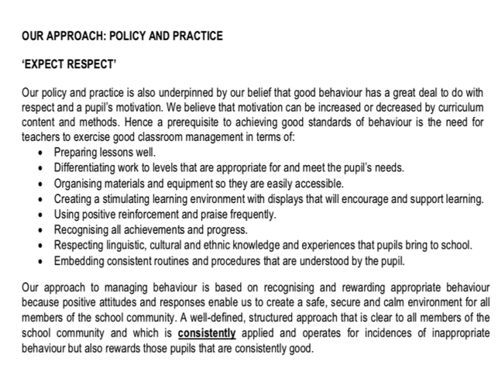

[APPENDIX C]

Pupil Trail Observations (List not exhaustive)
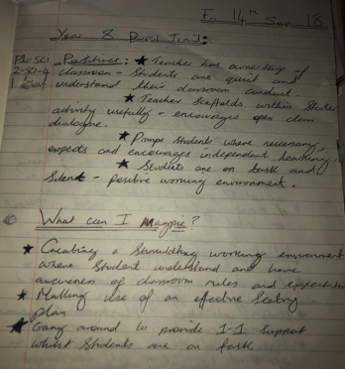





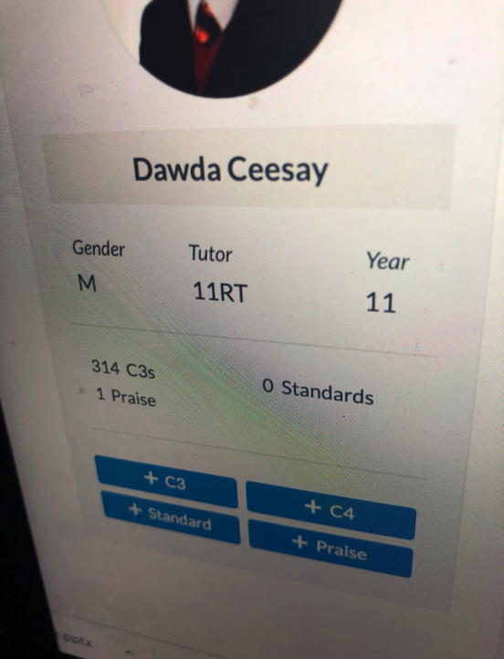
[APPENDIX D]
Pupil BFL record (Full pupil profile/incidences report confidential hence not fully disclosed)

